University in Banja Luka
Faculty of Electrical Engineering
Department of Automatic control

The first test in
AUTOMATIC CONTROL SYSTEMS
04.12.2015.

- [12] The system has the following transfer function in an open loop:
$$W\left(s\right)=\frac{K}{s^{2}+2s}$$
Draw the root locus diagram and then, based on it, determine the gain K for which the system with a closed unit negative feedback has a pole with equal real and imaginary part, different than 0.
- [13] Determine the transfer function of a sytem in Fig. 2.1.
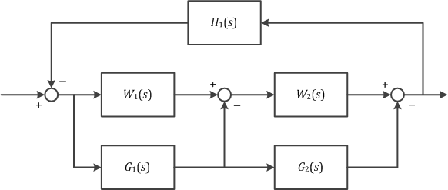
Figure 2.1 Block-diagram of a system
After that, suppose the following $W_{1}\left(s\right)=\frac{s+2}{s^{3}+10s^{2}+8}$, $W_{2}\left(s\right)=1$, $G_{1}\left(s\right)=1$, $G_{2}\left(s\right)=-1$ and $H_{1}\left(s\right)=a-3$, and then check the stability of a system in regard to parameter $a$ using Nyquist criterion.

Maksimum number of points available for each task is given in brackets at the beginning of the task.
Minimum number of points to pass the first part is 13.
Working time is 90 minutes.

